HANDS FOR PEACE
The Richmond Arts and Culture Commission is sponsoring “Hands for Peace” in participation with the Global Art Project. We invite you to get involved. Here are several ways you can choose to join in:
* Make a hand according to the instructions below.
* Invite others to make hands.
* Contribute a monetary donation for art supplies, or any variety of supplies that we will distribute to schools, community centers and other organizations where children will be making hands.
* Display hands at your business or public space by mid-November (making sure to let us know where this will be so we can publicize the information.)
The Global Art Project invites you to join hands with thousands of others around the world to celebrate peace and diversity. Here's how you can participate:
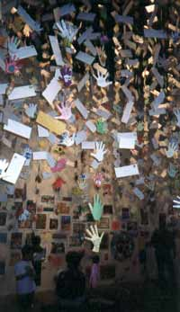
In September 1999, all of the hands submitted for Let's All Join Hands were displayed at the Tucson Museum of Art.

- Outline your hand on paper.
- Cut out the paper hand.
- Color and decorate both sides of the paper hand.
- Write your name, state and country in your native script on one side.
- Write your personal wish for global peace, love and friendship on the other.

Drop off monetary donations, or art supplies by 10/31, and “hands” by mid-November, to the Richmond Arts & Culture Commission, 3230 Macdonald Ave., or the Richmond Chamber of Commerce, 3925 Macdonald. Call (510) 620-6952 for more information.

